Chapter 05: Implementation of Sorting Algorithms
HND CSD
BCAS Campus, Kalmunai
By: Eng. A.L. Jubailah Begum
data structures & algorithms

Bubble Sort
Bubble Sort is the simplest sorting algorithm that works by repeatedly swapping the adjacent elements if they are in wrong order.
Following is the implementation of Bubble Sort.
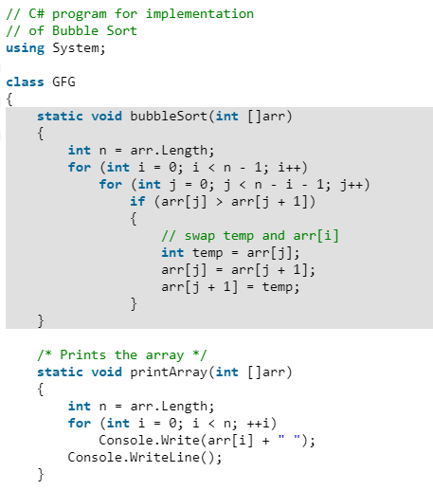
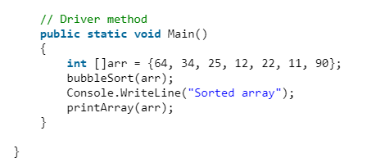
Illustration for the code:

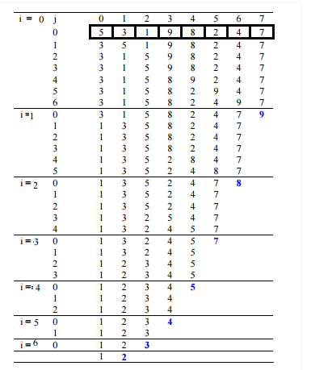

Selection Sort
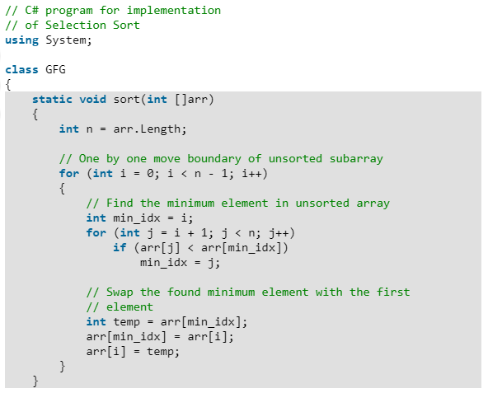
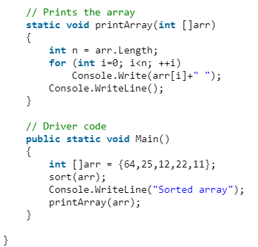

Insertion Sort
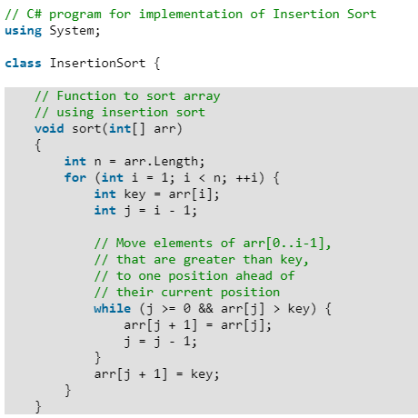
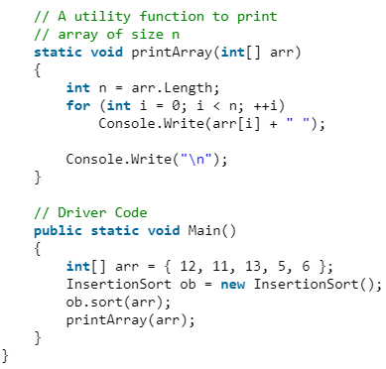

Quick Sort

Following is the implementation of Quick sort.
